 [Translated from German to English - www.onlinedoctranslator.com](https://www.onlinedoctranslator.com/en/?utm_source=onlinedoctranslator&utm_medium=docx&utm_campaign=attribution)

**1.1 Functional description**

Separation magazine Technical documentation

0 by Dr.-Ing. Paul Christiani GmbH & Co. KG 1

The separating magazine can accommodate up to 10 stacked workpieces. A pneumatic cylinder controlled by a 5/2-way valve pushes the bottommost workpiece out of the stack. A limit switch monitors the magazine's loading status.

The functional module is completely built on a mounting platform measuring 80 x 230 mm and can be flexibly mounted individually or together with other functional modules on an aluminum profile plate.

Two 8-bit transfer connectors are available as interface modules for connecting to a PLC. Three digital PLC inputs and two digital PLC outputs are required. The supply voltage of the function module is 24 VDC.

The compressed air connection with approx. 4 bar is made via 4 mm connections.

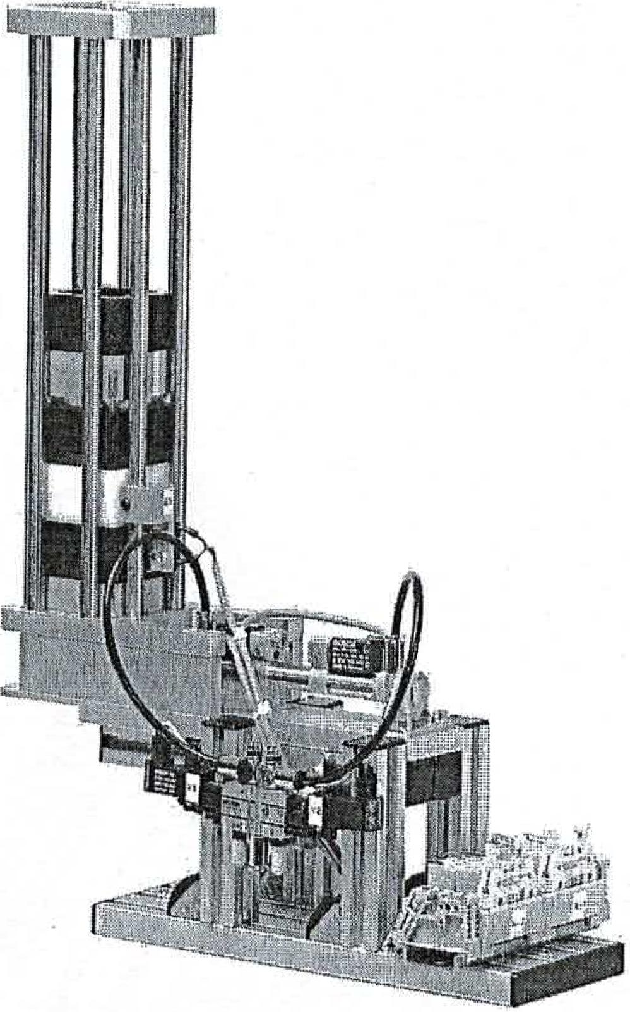

**1.1 Functional description**

Separation magazine Technical documentation

© by Dr.-Ing. Paul Christian' GmbH & Co. KG 1

The separating magazine can accommodate up to 10 stacked workpieces. A pneumatic cylinder controlled by a 5/2-way valve pushes the bottommost workpiece out of the stack. A limit switch monitors the magazine's loading status.

The functional module is completely built on a mounting platform measuring 80 x 230 mm and can be flexibly mounted individually or together with other functional modules on an aluminum profile plate.

Two 8-bit transfer connectors are available as interface modules for connecting to a PLC. Three digital PLC inputs and two digital PLC outputs are required. The supply voltage of the function module is 24 VDC.

The compressed air connection with approx. 4 bar is made via 4 mm connections.

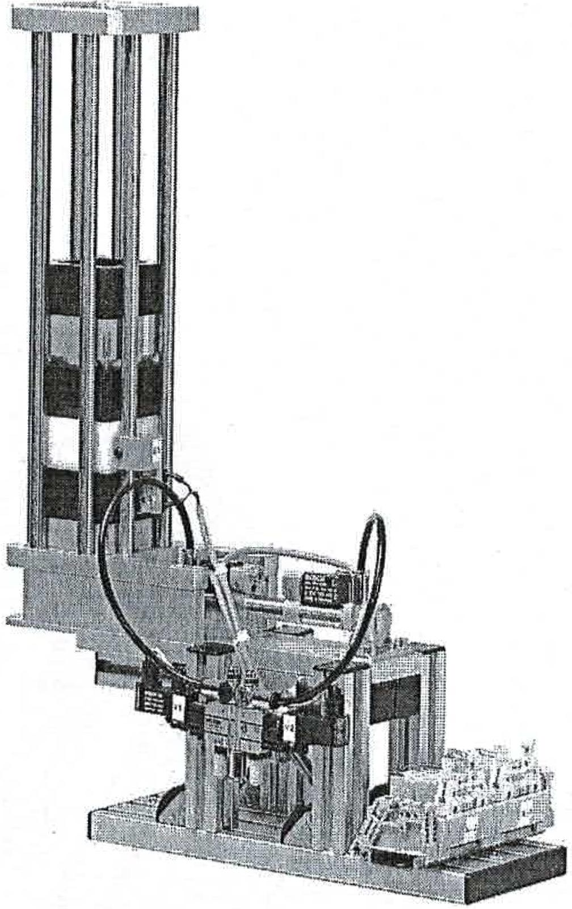

© by Dr.-Ing. Paul Christiani GmbH & Co. KG

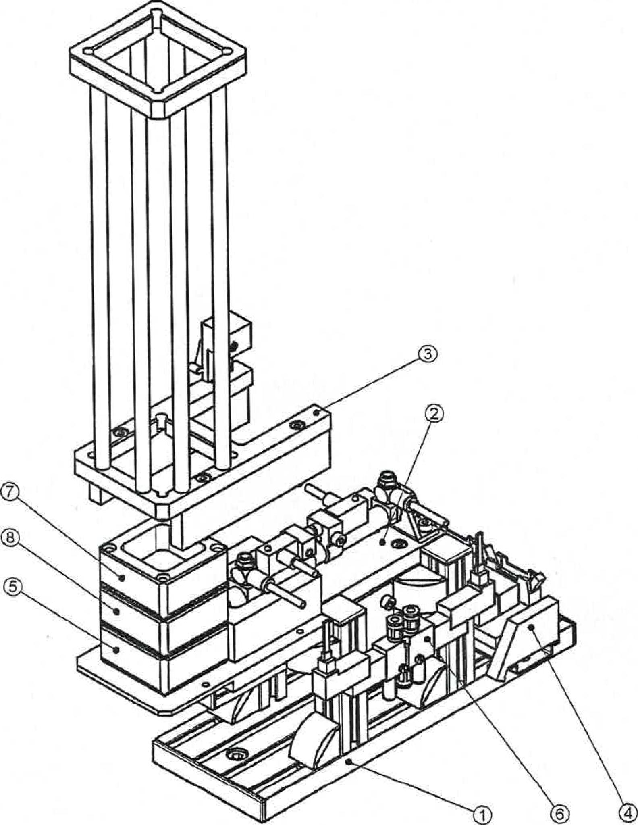

|  |  |  |  |  |
| --- | --- | --- | --- | --- |
|  | Item No. | designation | Christiani No. | Crowd |
| 1 | Construction set carrier | 33100059 | 1 |
|  | 21Kit  Insert | 33100061 | 1 |
| 3 | Bearing kit | 33100062 | 1 |
| 4 | Electrical connection | 33100019 | 1 |
| 5 | Workpiece 50x50x25 (aluminum) | 36053320 |  |
| 6 | Pneumatic directional valve | 33100060 | 1 |
| 7 | Workpiece 50x50x25 (POM well) | 360533 |  |
| 8 | Workpiece 50x50x25 (POM black) | 36053321 |  |
|  | | | |
| General drawing of the separating magazine drawing 33100058 05-11-2003Leaves: | | | | |

Christiani

Technical Institute for Education and Training

2

tr) Copyright Dr.-Ing. Paul ChristianiGmbH*8*Co. KG

**6unutiopziwesao**

ugeßews6uniezupioA

uopluewmioa etps!utpai